

Ecodash
  - Documentation
25302174 | Sanele ndlovu | was262

1. Project Overview
EcoDash is a browser-based drone delivery game designed to demonstrate how infrastructure, distance, energy availability, weather conditions, and community needs can affect logistics and delivery operations. It requires the player to control a delivery drone and is required to complete a series of delivery objectives while managing the drone's battery, navigating obstacles, responding to weather conditions, and using available charging infrastructure.
2. Development Process
The development of EcoDash followed several stages.
Concept Development
The initial concept focused on creating an interactive game that could demonstrate real-world logistics challenges in a simple, engaging and fun way.
The main learning objectives were to demonstrate how factors such as distance, Infrastructure, Battery capacity, wethaer and delivery requirements can influence the success of the whole operation I used drone delivery concept was selected because it allowed these factors to be represented through visual gameplay mechanics rather than only through written explanations.
Interface and Wireframe

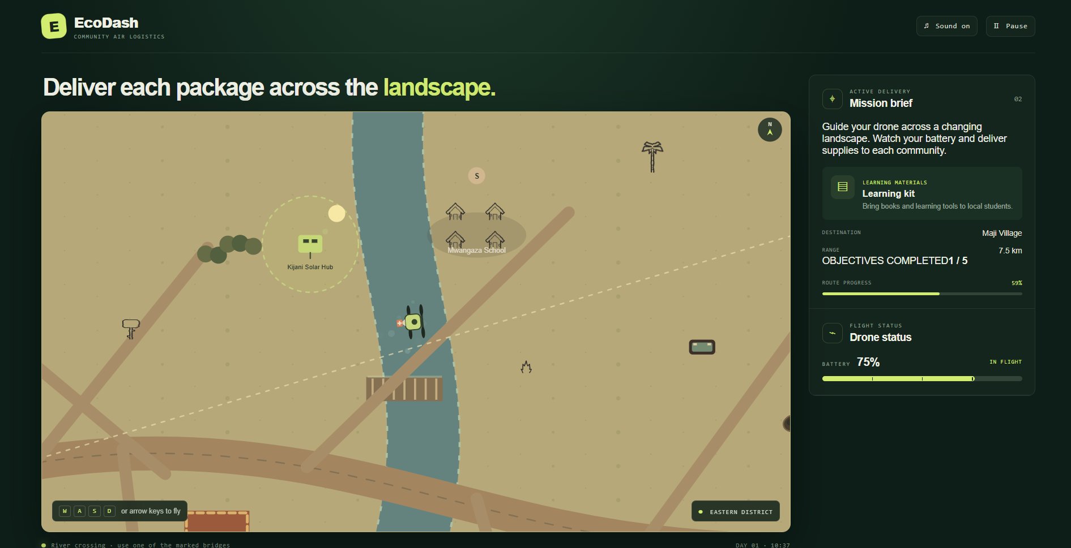
The main components of the interface include:
- Game Header: Displays the EcoDash logo and game title, along with controls for turning the game sound on/off and pausing the game.
- Mission Heading: Provides the current objective to the player, for example in this image, it is “Deliver each package across the landscape.”
- Interactive Game Map: The central section displays the game environment, including roads, rivers, bridges, buildings, trees, solar hubs and other landmarks. The player controls the drone within this environment.
- Drone: The drone is positioned within the map and represents the player's controllable character/object.
- Navigation Controls: The interface indicates that the player can use the W, A, S, D keys or arrow keys to control the drone.
- Mission Brief: The right-hand panel provides information about the current mission and explains the task the player has to complete.
- Destination: Shows where the package must be delivered.
- Range: Indicates the player has travelled
- Objectives Completed: Tracks the player's progress through the required objectives.
- Route Progress: A progress bar visually indicates how far the player has progressed along the current route.
- Flight Status: Displays the current condition of the drone and its battery percentage so the player knows when its low
- Location Indicator: Identifies the current district or area of the game map.
- Game Information: The bottom section provides additional environmental or gameplay information, such as river-crossing instructions and the current in-game day and time.

System Development
The game was separated into several JavaScript modules, with each module responsible for a specific part of the game.
- player.js – controls the drone, movement and player-related behaviour.
- missions.js – manages delivery destinations and mission progression.
- weather.js – controls weather-related effects and conditions.
- obstacles.js – defines hazards and obstacles within the game world.
- game.js – coordinates the main game systems, gameplay logic and rendering.
- main.js – connects the game with the HTML interface and updates information displayed to the player.
Separating the project into modules helped keep the code organised and made each system easier to adjust.
Interface and Presentation
After the core gameplay was functional, additional interface and presentation features were implemented.
These consisted of:
- Start and pause functionality
- Game status information
- Battery and telemetry information
- Objective tracking
- Visual effects
- Sound and audio feedback
- A dedicated victory state
- A simplified sidebar
- A blue visual theme
These features were added to make the game easier to understand and provide clearer feedback to the player.
3. Development Challenges
Consistent Movement
One challenge when developing browser games is ensuring that movement remains consistent across different computers and frame rates. EcoDash uses elapsed time, or deltaTime, when calculating movement and other time-dependent behaviour. This means that movement and battery consumption are based on the amount of time that has passed rather than simply the number of frames rendered. This approach helps prevent the game from behaving significantly differently on computers with inconsisent performance levels.
Battery and Route Balancing
Battery management is an important part of EcoDash because the player needs enough energy to complete deliveries. Factors can affect energy usage, including movement, weather conditions and the route being travelled. Charging stations provide opportunities for the player to recover energy. These systems need to be balanced carefully. If battery consumption is too low, the mechanic becomes insignificant. If it is too high, missions may become unnecessarily difficult.
Collision Detection
The game uses different collision approaches depending on the type of obstacle that the drone encounters . Circular hazards can be checked using the distance between the drone and the centre of the hazard. Rectangular obstacles use the nearest point on the rectangle to determine whether the drone has entered the obstacle. The river also contains additional logic that checks the drone's previous and current position. This allows the game to detect attempts to cross the river and restrict crossings except where bridges are available.
Connecting Multiple Systems
Another challenge was ensuring that different systems remained synchronised. Completing a delivery can affect several parts of the game simultaneously. For example, Current mission, Score. Progress and Player stuatus as well as audio.
This is because these systems interact with each other, changes to one component can affect the behaviour of another component. This helped keep separate classes and modules organised.
Browser Audio and Storage
Browser-based applications can have restrictions around audio playback. In particular, browsers may prevent audio from automatically playing before the user interacts with the page. This required the game's audio behaviour to be connected to user interaction and game states. Browser storage was also considered because locally opening a web project can behave differently from running the project through a web server.

4. Technical Concepts
Game Loop
The game uses requestAnimationFrame() to create the main game loop. The browser repeatedly requests a new frame. During each frame, the game updates the current state and then redraws the game world. The time between frames is measured using deltaTime. This allows movement and other time-dependent calculations to be based on elapsed time rather than frame count.
Vectors and Movement
Keyboard input is converted into horizontal and vertical movement values. The movement direction is normalised so that diagonal movement does not provide an unintended speed advantage. Trigonometric calculations using sine and cosine are then used when converting directional information into movement and acceleration. Wind can also influence the drone's movement, adding another environmental factor to navigation, enhancing the realism in the game
Separation of Responsibilities
The project uses separate classes and modules so that different systems are responsible for different tasks. For example, the Player Drone class manages the drone, while the Mission Manager manages delivery objectives and the Weather System manages weather. The main Eco dash game class coordinates these systems. This approach follows the principle of separation of responsibilities thus making the project easier to maintain and modify.
5. Ai Reflection
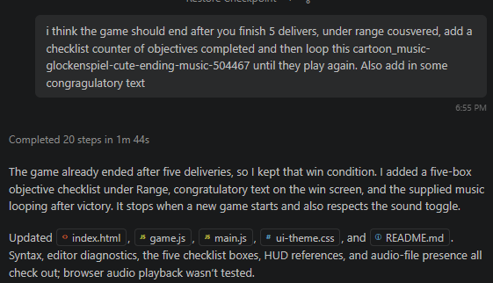
I used GitHub Copilot to assist with implementing the game's audio system. I provided Copilot with the specific audio files and explained when each sound should play. Copilot traced the existing audio lifecycle and connected the sounds to the appropriate gameplay events.
Copilot implemented a looping background track during active gameplay, a startup sound when the game begins or restarts, a delivery sound for each completed delivery, and an achievement sound when all five deliveries are completed. It also ensured that the background audio responds to pause, game-over and the sound toggle.
Copilot checked that the four MP3 files existed in the project, updated game.js and README.md, and ran a JavaScript syntax check. The final implementation was reviewed and tested as part of completing the project.
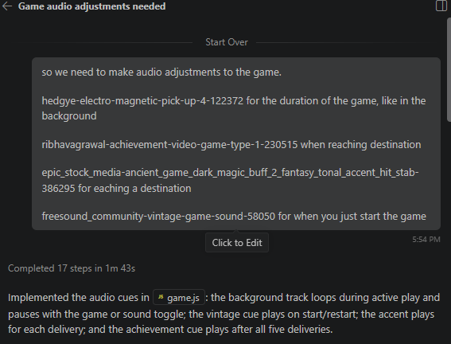

6. Final Outcome
The completed EcoDash project is a functional browser-based game that combines several interconnected systems into one playable experience. By incorporating Weahter Effects, Mission progression, Visual effects, Audio Feedback, Battery management making this immersive experience, demonstrating how JavaScript can be used to combine gameplay logic, user interaction, environmental simulation and interface updates into a single web application.

